How to edit texts, tables and presentations in Yandex Documents
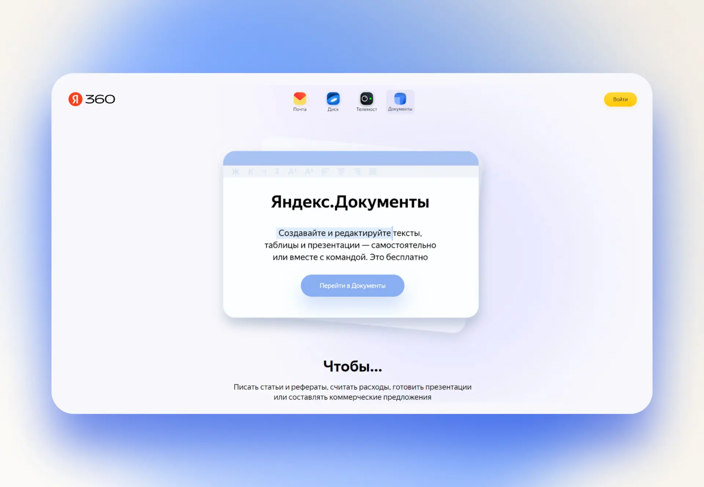
Click "Go to Documents." The service will prompt you to enter your login and password. If an account in Yandex is already open, when you click on the link you will immediately see the start page of the service

The start page greets you with three key areas. At the top is a panel with links to other Yandex 360 services and the account menu. On the left are the “Documents”, “Tables”, “Presentations” and “Scans” tabs. Most of the window is occupied by the “Recent Documents” field with file icons.
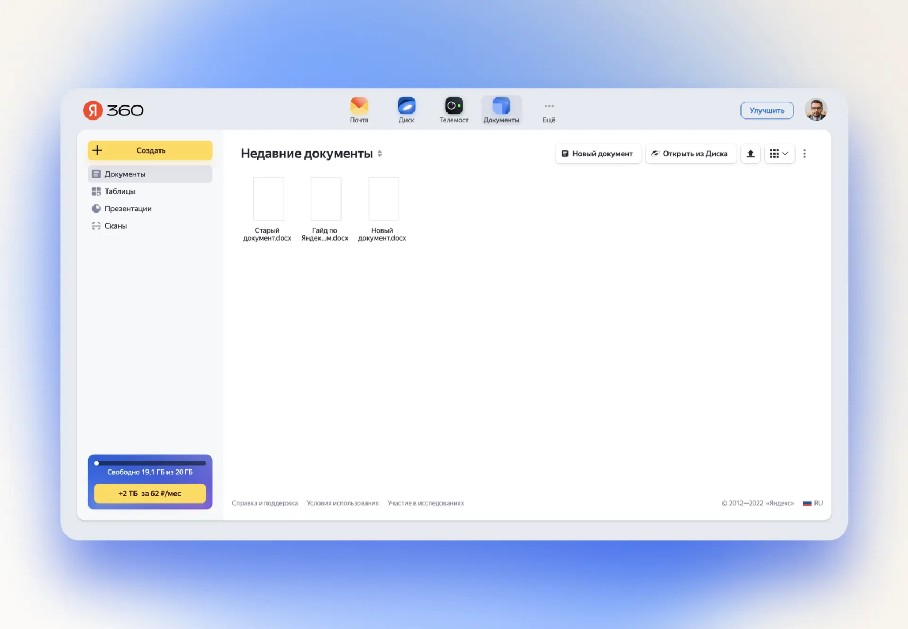
Yandex Documents start screen

How to sort files. By default, files are sorted by viewing date. To sort them by name or size, click on the name of the “Recent Documents” field. Here you can select the display order: ascending or descending.

To the right are the buttons “New Document”, “Open from Disk” and the up arrow - load a file from your computer.
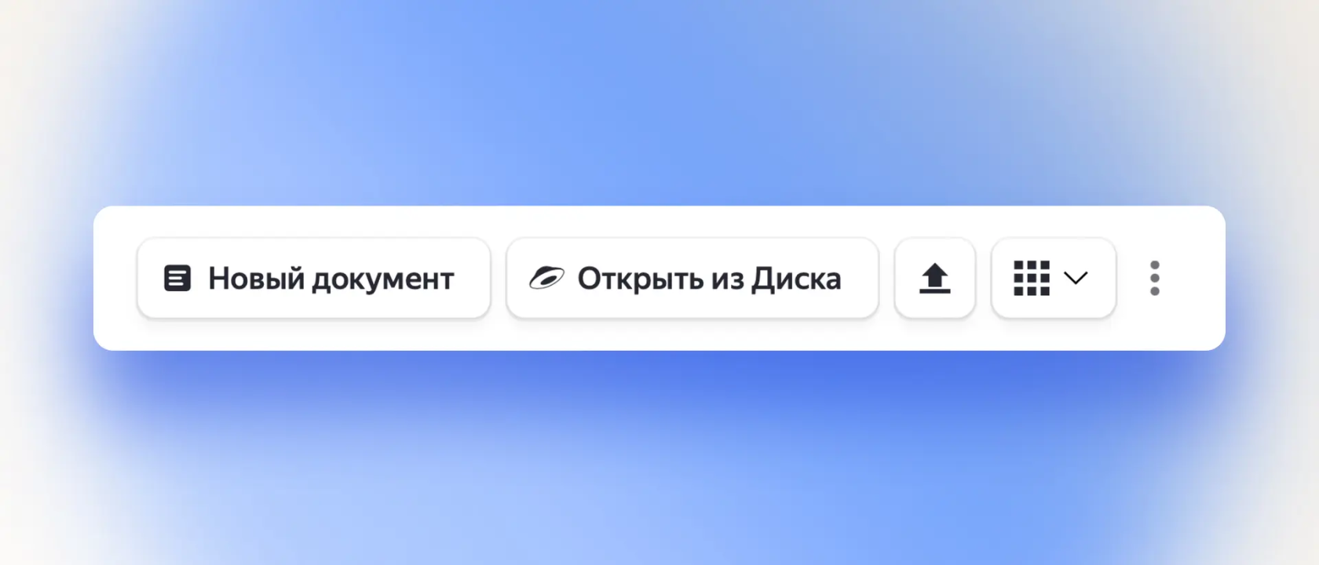
File management buttons in Yandex Documents

The last two buttons in the row are responsible for:
- Select a document display style - two types of tiles or a list.
- Filter by file author. You can select only your files, or those that other users have shared with you, or all at once.

How to pin an important file to the top of the list. Just hover your cursor over it and click on the icon with a pushpin that appears. Now the document will always remain on top, regardless of the filter and sorting.

How to create a document

Click on the "Create" button and select: "Document", "Table" or "Presentation".
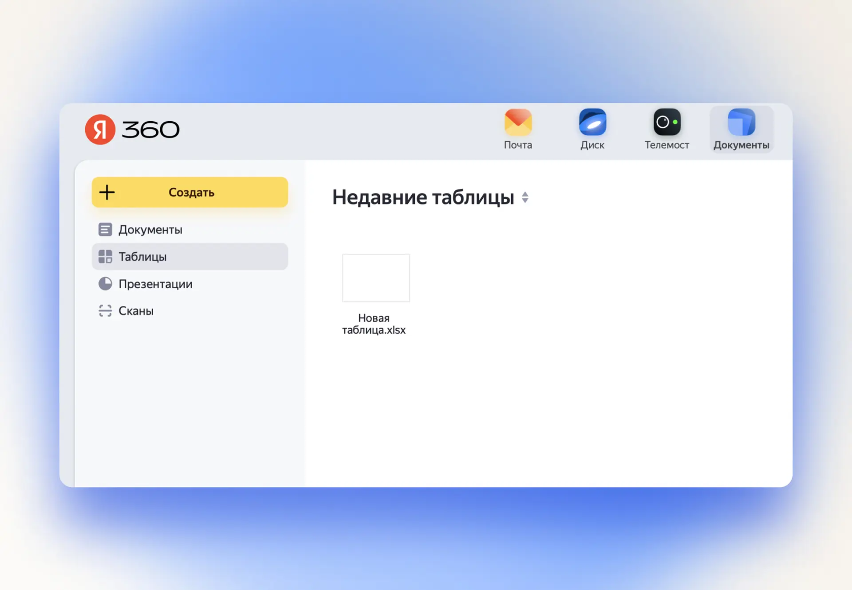

A name entry field will appear. Provide a file name and click Create again.
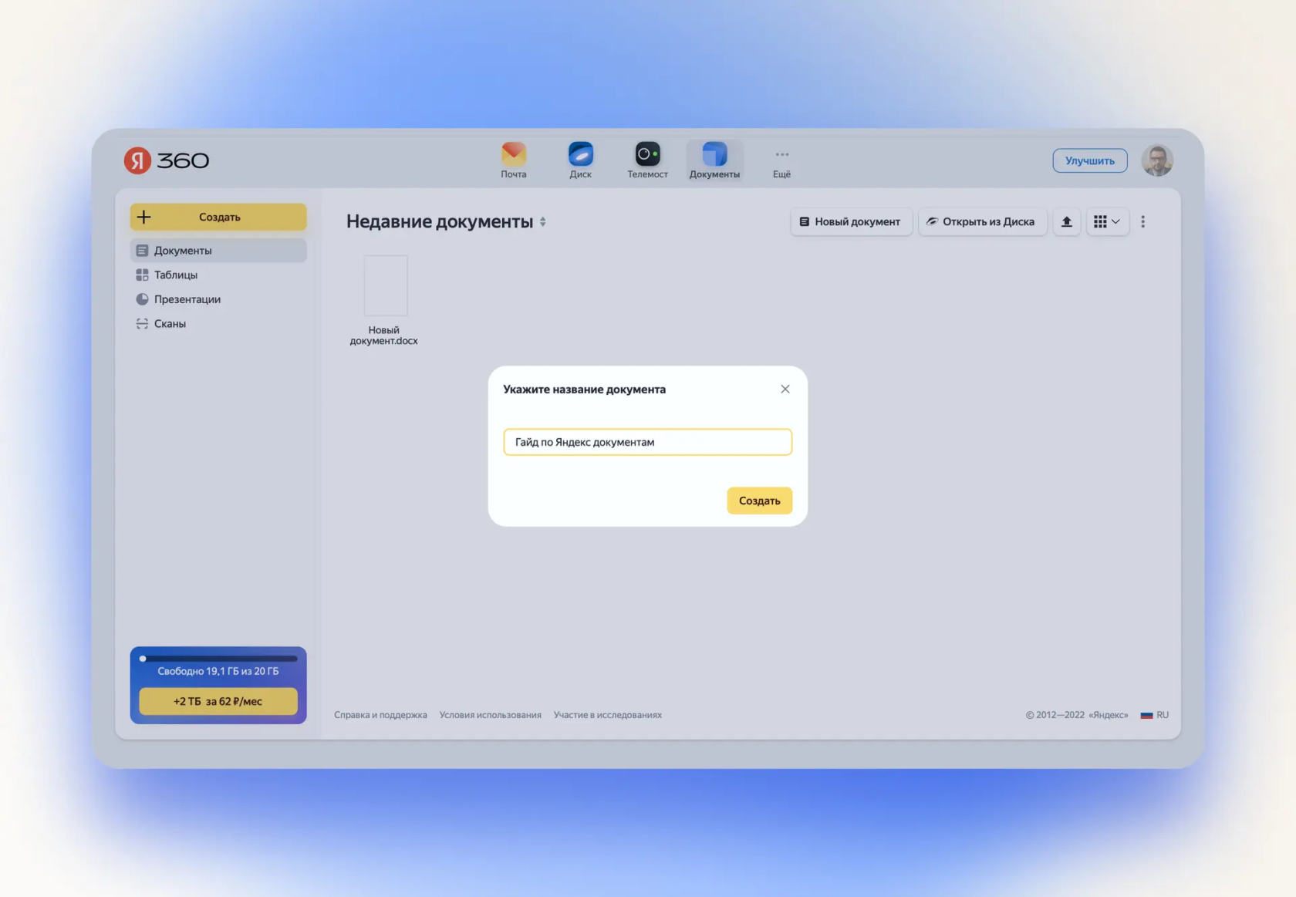

The newly created file will open in a new tab and you can edit it.

How to edit documents

Documents has three editors: for text documents, tables and presentations. The interface is similar to the usual offline office applications.

At the top there is a ribbon of tabs - a menu. It starts with the "File" drop-down list. With its help, you can upload documents to your computer, send them for printing, set a password, or go to the editor settings.
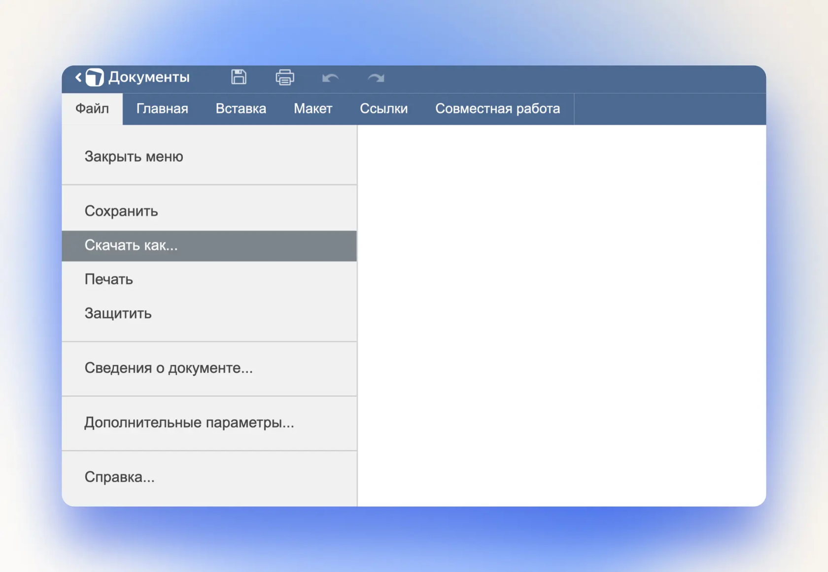
Tab ribbon and open “File” menu in Yandex Documents

The following tabs conveniently group functions. On the Home page there are the main buttons for working with the corresponding file type.

How to format text

To work with text, first of all, you need functions: changing the font, size and color, alignment. In all three editors they are located on the left side of the Home menu.

Write the text, select it with the mouse and click on the desired formatting button.

Clue. If you hover your mouse over a button, the name of the function will pop up on top of it.
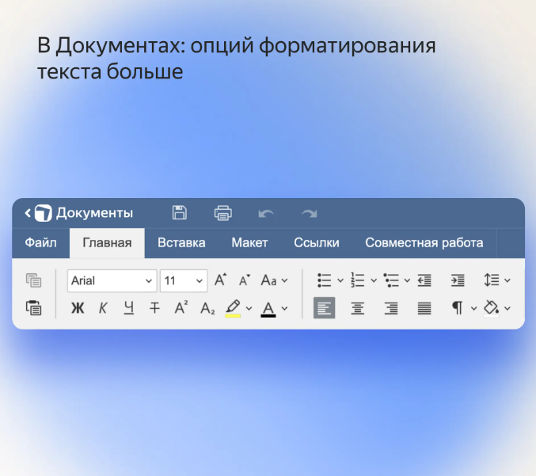
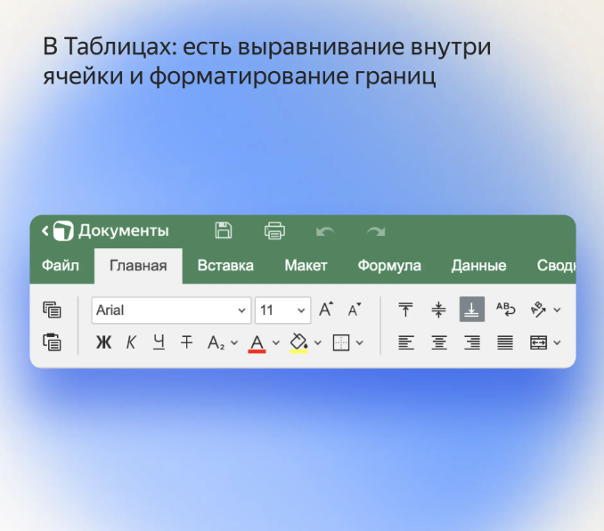
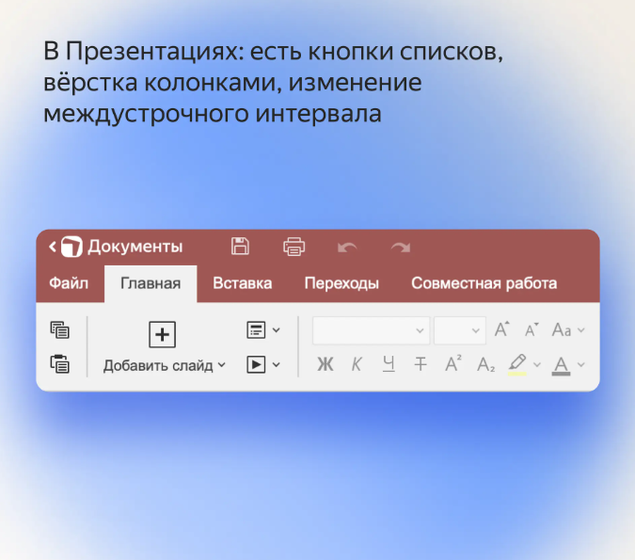

On the right side of the menu there are functions specific to each type of document. Scroll through the gallery to see which ones.

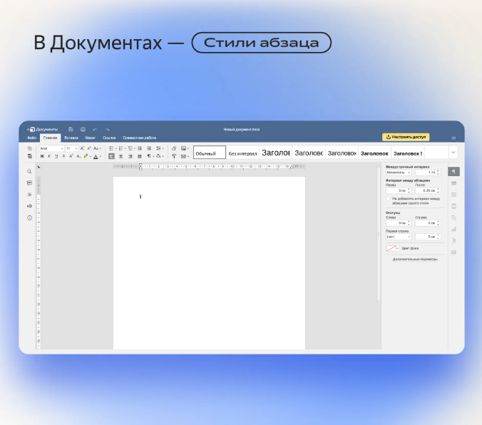
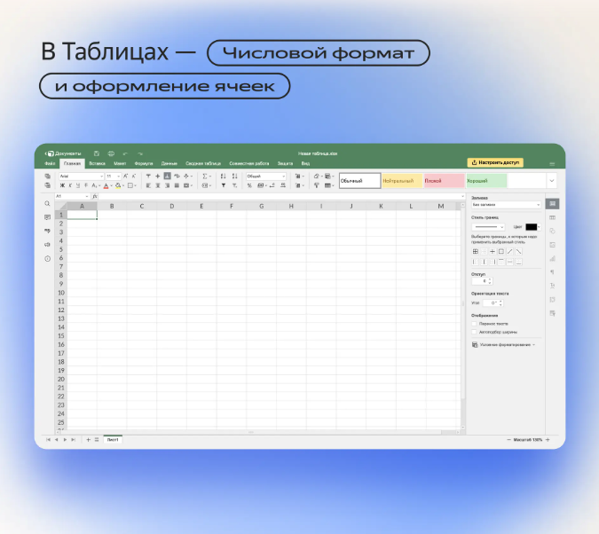
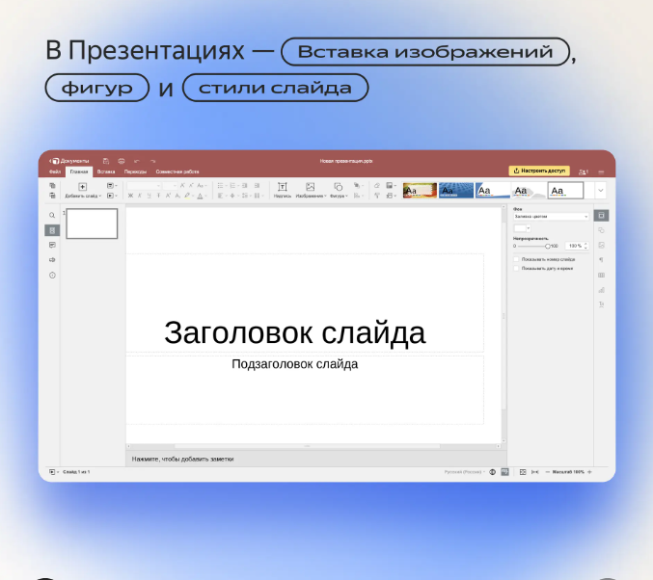

How to add an element

Go to the "Insert" menu and select the element you want:
- You can add a photo from your computer or via a link, table, graph, comment, link, footer to text documents.
- Tables have a smaller set of elements. But you can create a pivot table and more options for charts.
- In Presentations, in the “Insert” menu, there is also a button for adding a new slide.
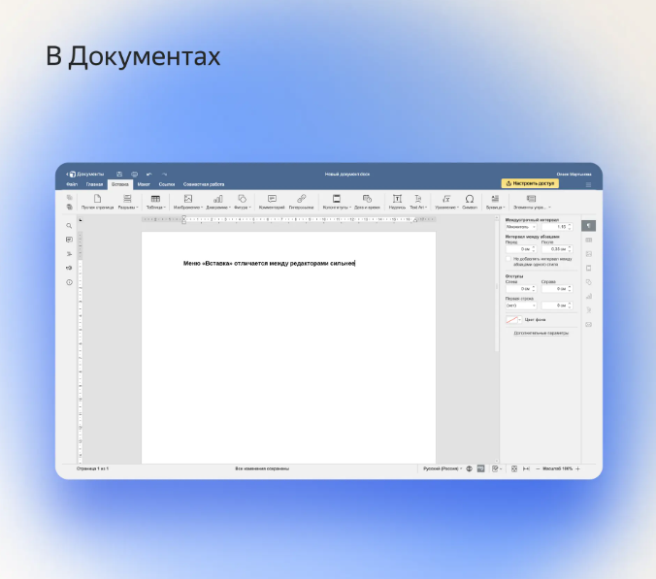
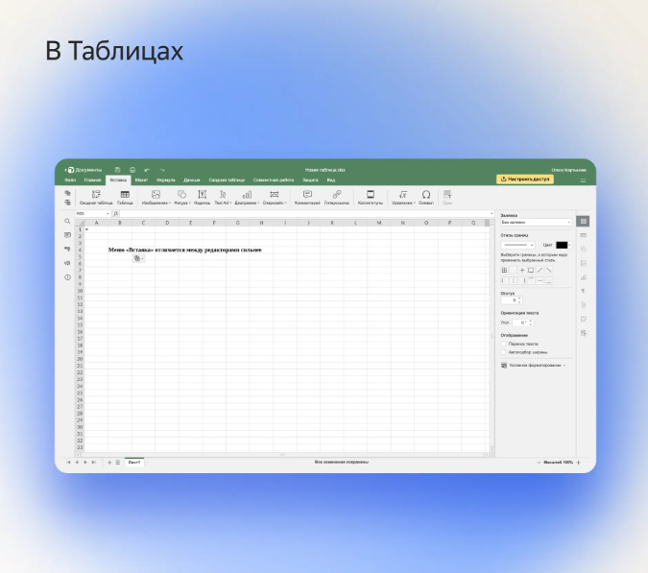
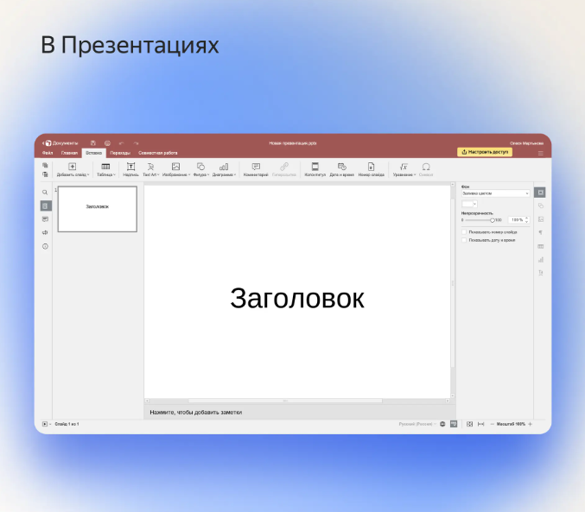

How to work with formulas

Working with formulas is only supported in Sheets. There are two ways to add a formula - through the menu in the top panel or by manual entry.

Method 1. Select the desired cell and go to the “Formula → Function” menu.
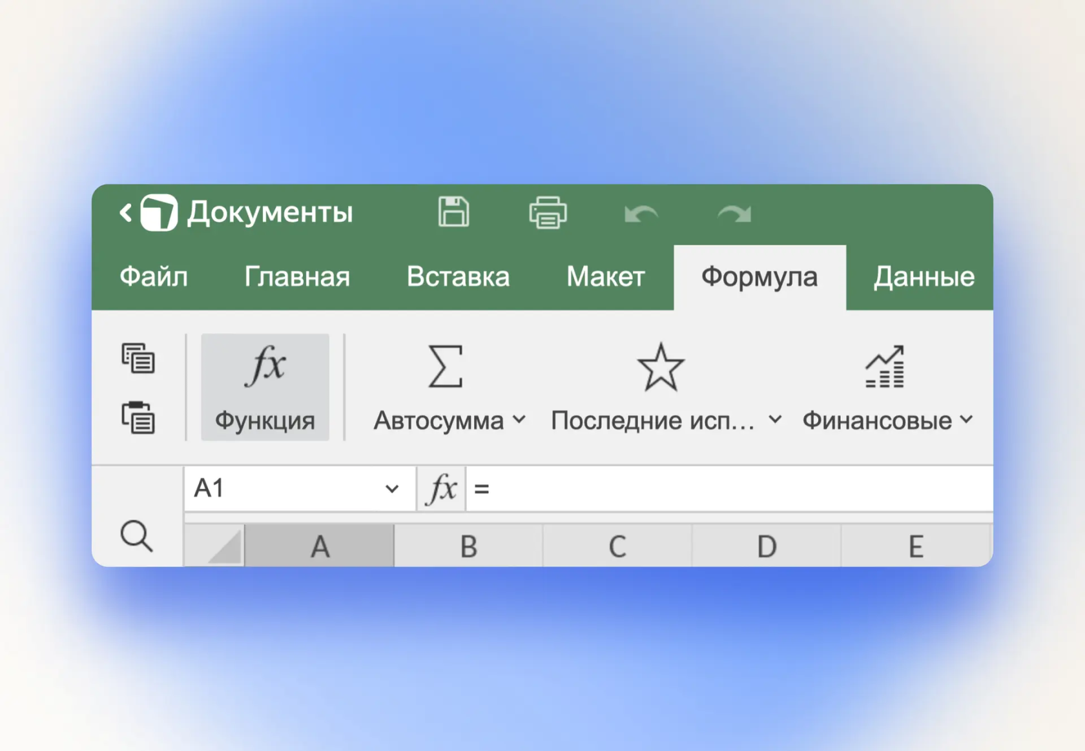
You can also insert a function using the hotkeys Shift + F3

A list of functions will open. They can be grouped into categories - for example, engineering, mathematics, logic. Highlight a function by clicking on it once, and its description will appear below the list. Click OK if it fits.
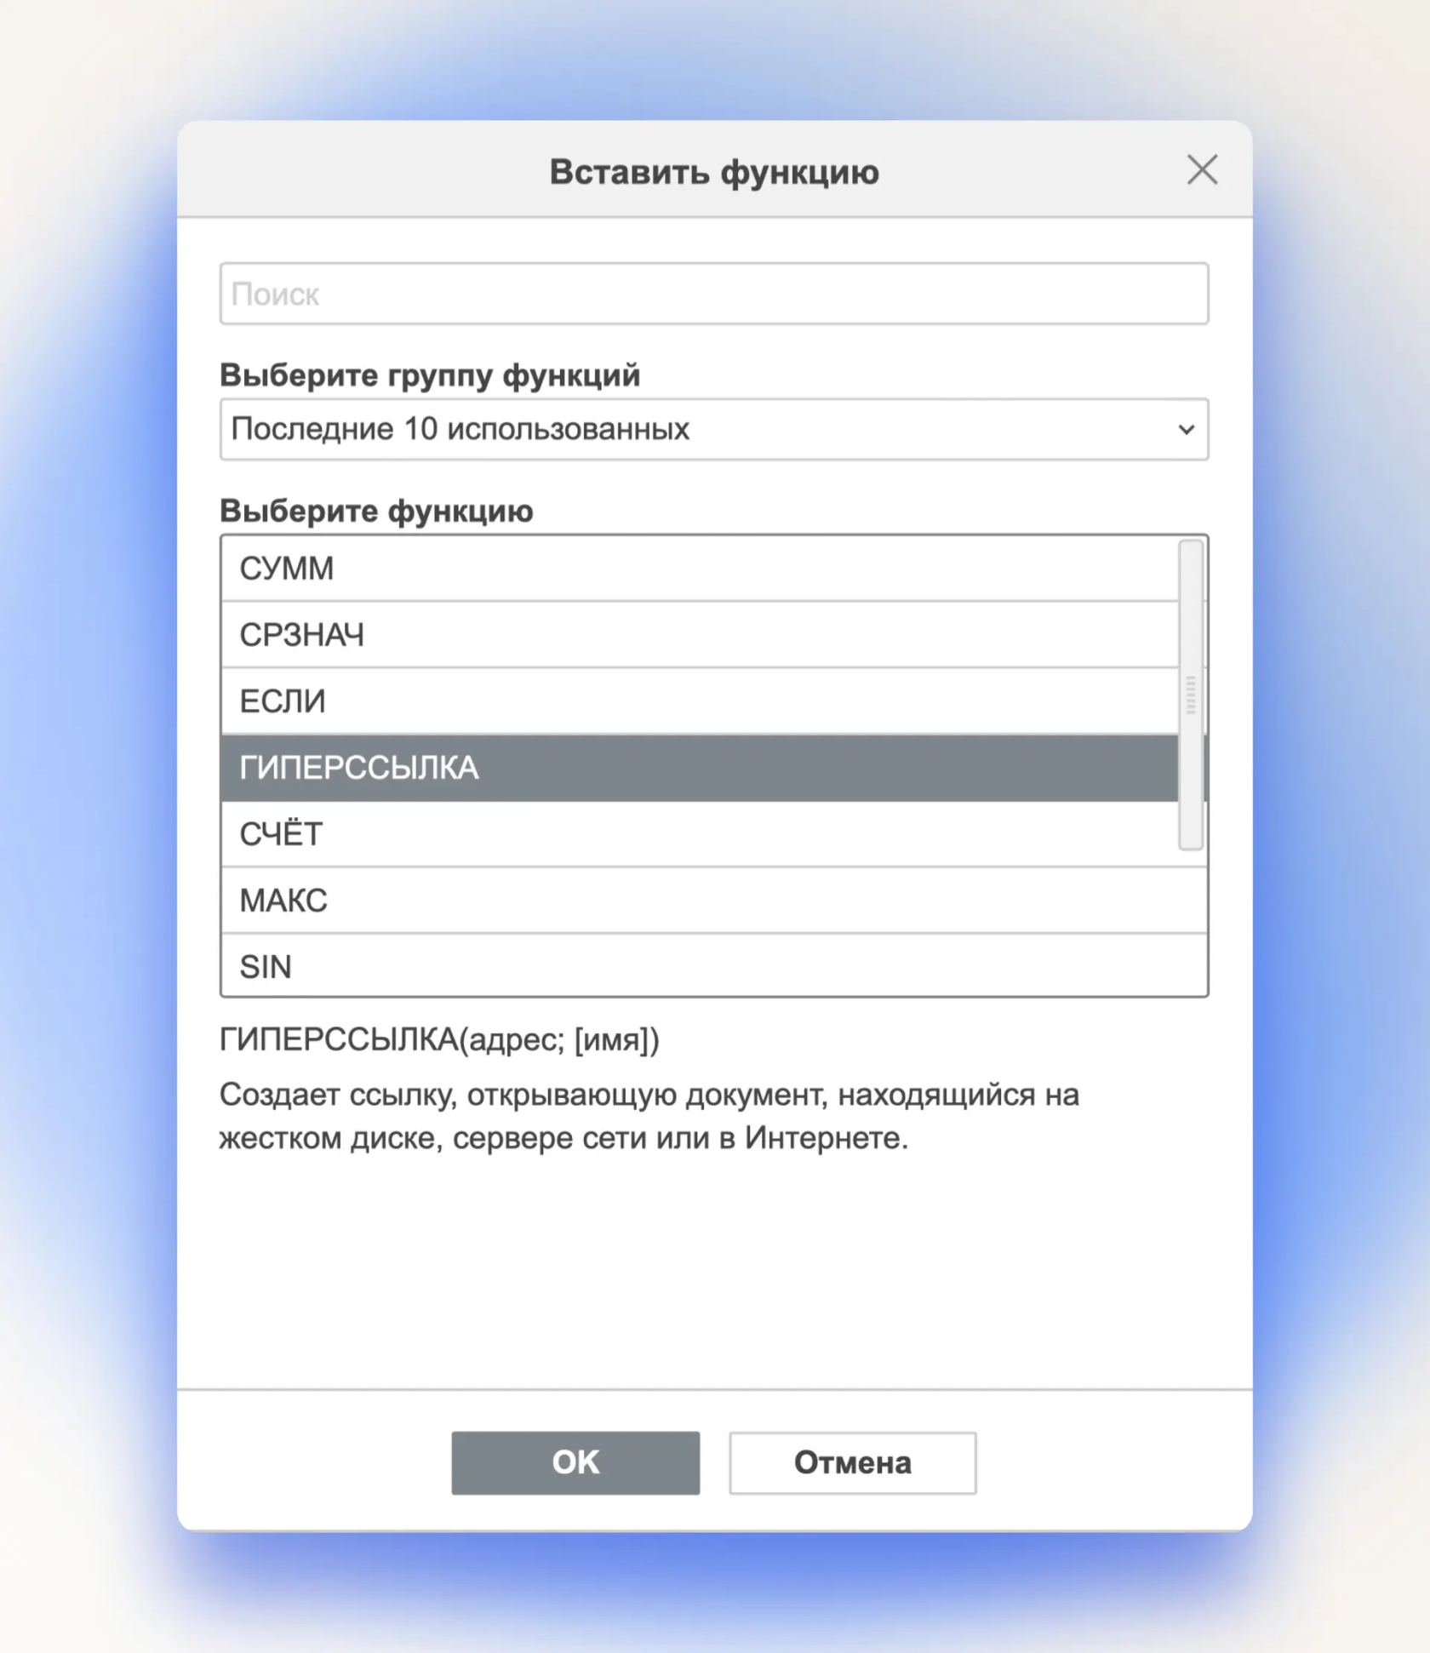
This method is convenient if you don’t know for sure which function is responsible for what.

Method 2: Put an equal sign in the cell. Start writing the name of the function. A drop-down list with tips will appear under the cell. Select the desired function and set its parameters.
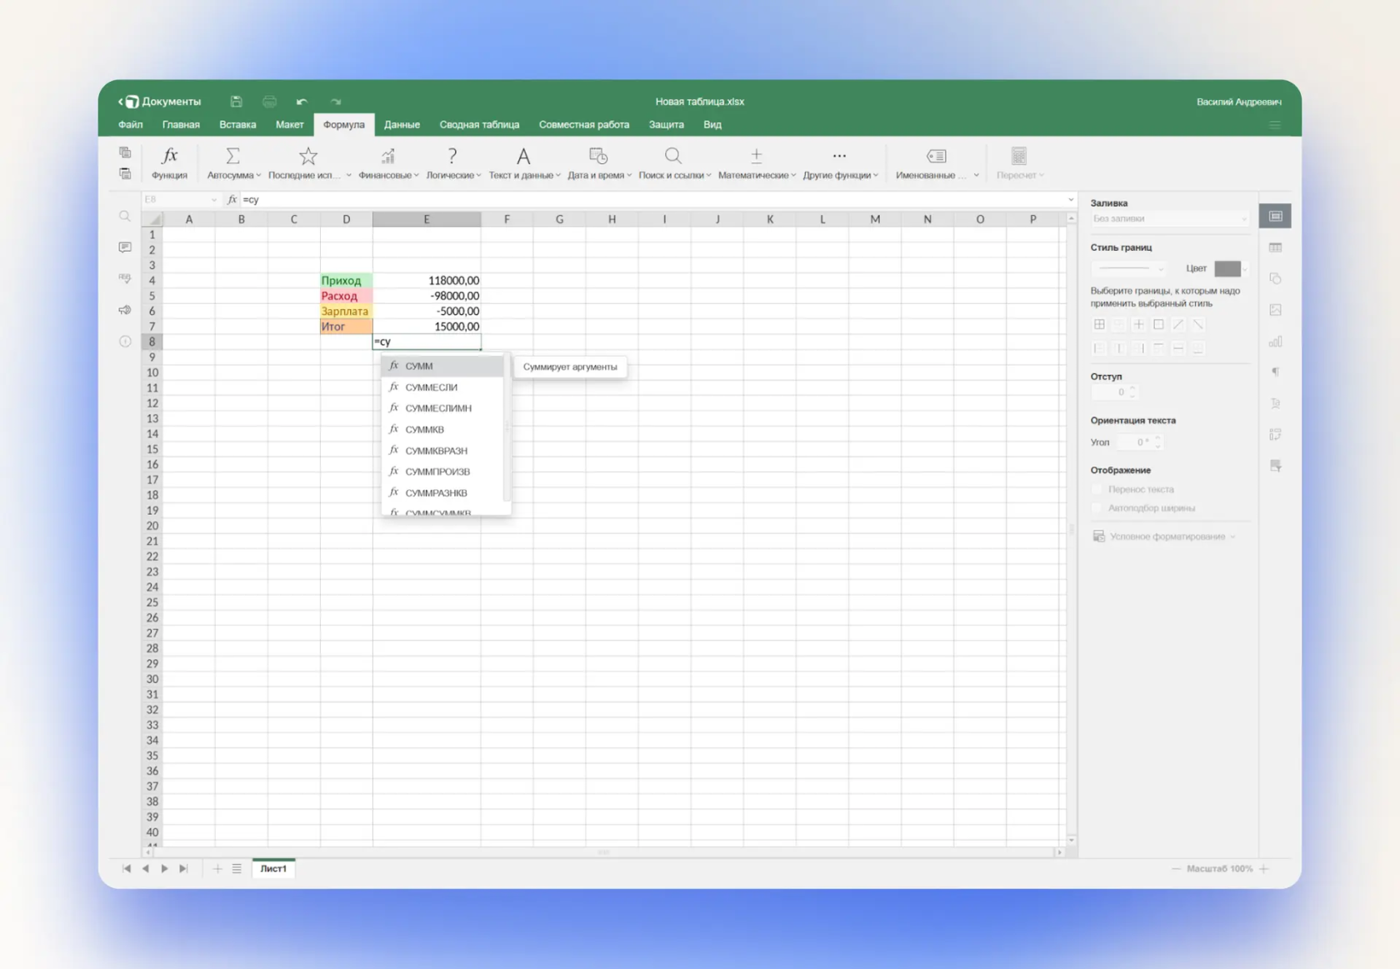
An example of manually writing a formula with a hint

How to share

In order for up to 40 users to work with the file simultaneously, you need to configure access to it. This is done from the Yandex Documents start page:
- Select the document you want to share and right-click on it. A context menu will open. Select “Configure access” and in the window that opens, set viewing or editing rights.
- Copy the link to the file and email it to your colleagues. Or show the QR code of the document to be read by your smartphone.

Owners of a Yandex 360 Premium subscription with Optimal and Advanced tariffs, in addition to standard sharing functions, can set a time limit during which the link will work. And also - prohibit downloading of a document when it is opened only for viewing.
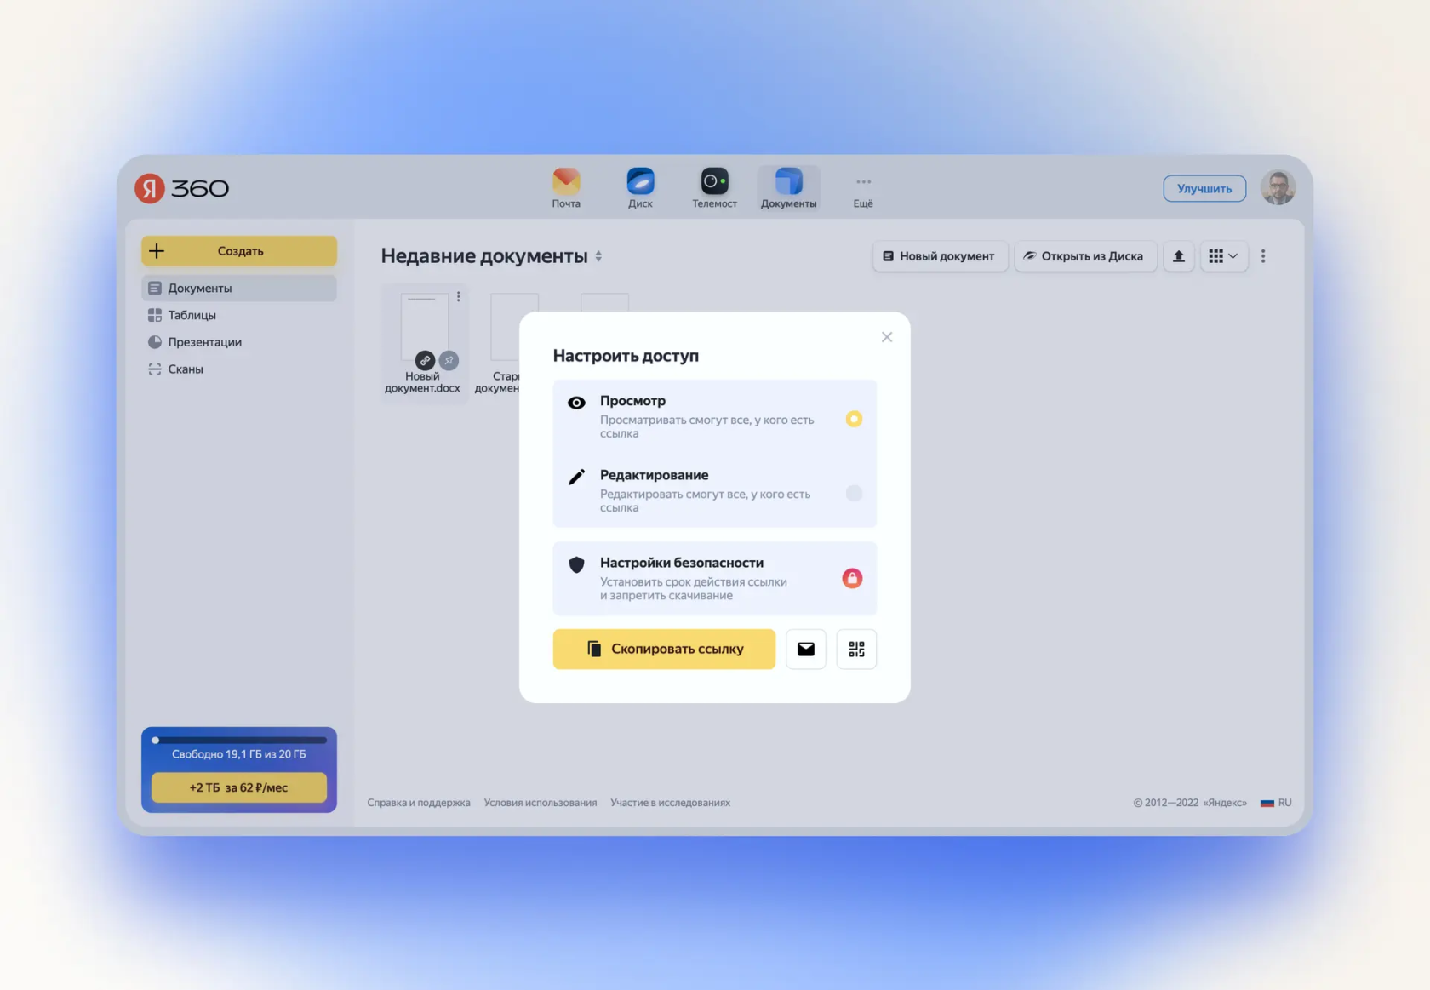
Window with document sharing settings

There are two co-editing modes - "Fast" and "Strict". The first is no different from working alone. All changes are saved immediately as soon as the user makes them. Changes are immediately visible to all participants. But the “Strict” mode requires clicking the “Save” button in the upper left corner of the editor so that the result of one person’s work becomes visible to others.

To set the mode, go to the Collaboration tab in the document, spreadsheet, or presentation editor. Click Co-Editing Mode and choose either Fast or Strict.
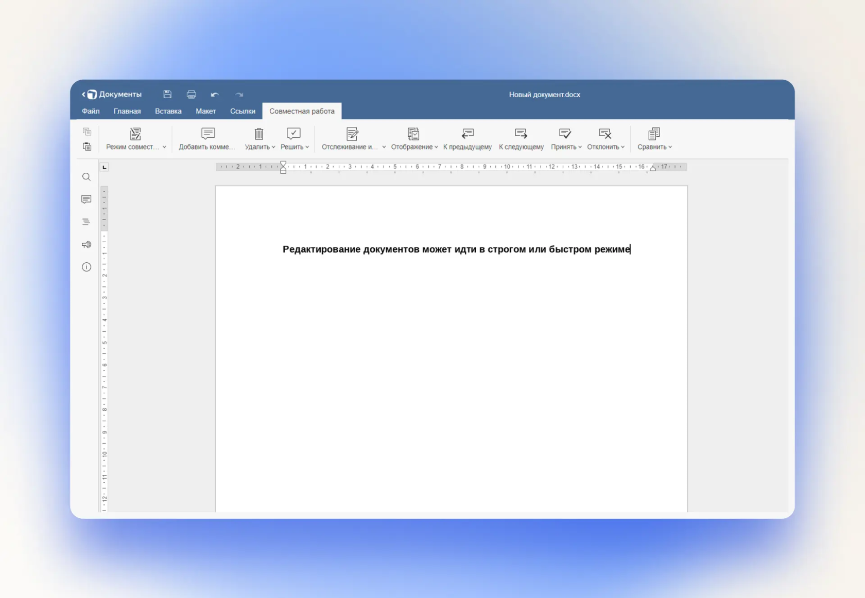
Selecting a collaboration mode in the document editor

How to save a document

Changes in Yandex Documents are saved automatically. Documents, spreadsheets, and presentations are stored on Drive in a manner familiar to Microsoft users Office formats - DOCX, XLSX and PPTX respectively. Through the “File” menu you can download them to your computer in PDF, OpenOffice , plain text (CSV for tables) and some others formats.

Important. If you are editing a document in strict sharing mode, you need to save it manually using the floppy disk button in the upper left corner of the editor or the keyboard shortcut: Ctrl + S for Windows or Cmd + S for macOS .

